• •  **Course Outcome to be covered:**

CO1: Merits of digital systems, various number systems and their applications.

**Outcomes :** Students will be know the difference between analog & digital along with its advantages & disadvantages.

• **Why Computer Engineers need to know about Digital Electronics system?**

* Suppose you write a code or design software. You feel that you have written a very perfect error less code but machine do not respond accordingly. You don’t know how, or why, but due to some fault or bottleneck in the hardware, or its architecture, your code is either not running or is running but not effectively.In this scenario, if you have an idea of how your hardware is actually interacting with the code that you have written then you can easily fix the problem and get on with your work. And because most of the components on a computer are electronic and work on digital signals only studying DIGITAL ELECTRONICS is useful.
* Computer science and engineering has several fields of electrical engineering and it required to form computer hardware and software. Computer engineers have training in electronic engineering, software design, and hardware-software integration instead of only software engineering or electronic engineering. Right from the design of individual micro-controllers, microprocessors, personal computers, and supercomputers, to circuit design computer engineers participate in many hardware and software factors of computing.

**Digital Electronics (History)**

The binary number system was refined by Gottfried Wilhelm Leibniz  (published in 1705) and he also established that by using the binary system, the principles of arithmetic and logic could be joined. Digital logic as we know it was the brain-child of George Boole in the mid 19th century. The inception of digital electronics started with the electronic circuit or gate which was invented in 1835 by Joseph Henry. In the next century, a vacuum tube was invented.

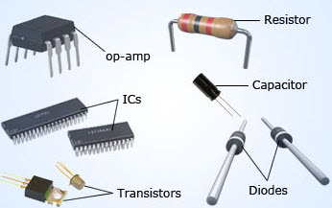

Fig [1.1]: Advancement over Conventional Electronics made in 1947

After the invention of various devices, different gadgets were introduced later on. The most useful inventions were that of microprocessors and integrated circuits which helped in the development of the present digital electronics. In an 1886 letter, Charles Sanders Peirce described how logical operations could be carried out by electrical switching circuits. Eventually, Vaccum tubes replaced relays for logic operations. Lee De Forest's modification, in 1907, of the Flaming valve  can be used as an AND gate. Walther Bothe, inventor of the coincidence circuit, shared the 1954 Nobel Prize in physics, for the first modern electronic AND gate in 1924.

The latest developments which are taking place in the sector of digital electronics have a great influence on kids and teenagers. And thus the present generation has earned the title of ‘digital generation’. It’s a common sight to notice children all around the world with digital phones, interactive TVs, palm pilots, laptops and many other such devices. This is exactly why young people are considered the main target group of companies which manufacture digital electronics.

**What is Digital Electronics..???**

Digital electronics is a field of electronics involving the study of digital signals and the engineering of devices that use or produce them. This is in contrast to analog electronics and analog signals. Digital Electronics is very important in today's life because if digital circuits compared to analog circuits are that signals represented digitally can be transmitted without degradation due to noise. Also in digital system information stored is easier than that of analog system.

**Needs of Digital Electronics:** 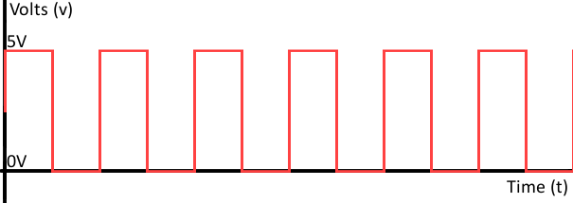

Fig [1.2] Digital Signal Representation of high & low w.r.t to Voltage Level

* Digital stand for digit, digital electronics basically has two conditions which are possible, 0 (low logic) and 1 (high logic).(Fig 1.2)
* Digital electronic systems use a digital signal that is composed of mathematical features to work. "1" as true and "0" as false are called bit and the group of bits are named byte.
* Digital describes electronic technology that generates, stores, and processes data in terms of two states: 1 and number 0.
* Digital electronic circuits are usually made from large assemblies of logic gates. (Will be discussed in detail in further lecture).
* A modem is used to convert the digital information in your computer to analog signals for your device and to convert analog signals to digital information for your computer.

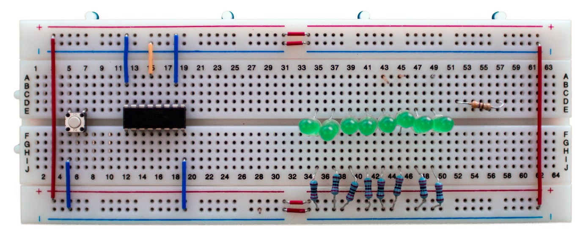

Fig [1.3] Logic Gate IC & Bread Board used for Digital Circuit Building

**Needs of Digital Electronics:**

Digital Electronics is very important in today's life because if digital circuits compared to analog circuits are that signals represented digitally can be transmitted without degradation due to noise.

* Digital signal is used in communication process to minimize the effect of noise.
* Digital Signals carry more information per unit time as compared to analog signals.
* Quality of digital signal is better overlong distance transmission.
* Use of bandwidth is less in case of transmission using digital signals.
* Data is represented in a digital system as a vector of binary variables.
* Digital Systems can provide accuracy (dynamic range) limited only by the number of bits used to represent a variable
* Digital systems are less prone to error than analog systems.
* Data representation in a digital system is suitable for error detection and correction.
* Digital systems are designed in a hierarchical manner using re-usable modules.
* Digital techniques are very useful because it is easier to get an electronic device to switch into one of a number of known states than accurately reproduce a continuous range of values.
* Digital electronic circuits are main thing in digital electronics which is usually made from large assemblies of logic gates. The system which process discrete values is known as digital system.
* The significance of digital electronics is that are inherently more reliable than analog, in terms of information processing.

**Merits & Demerits of Digital Electronics:**

**Merits of Digital System:**

* It is economical and easy to design.
* It is very well suited for both numerical and non-numerical information processing.
* It has high noise immunity. But in case of high speed designs a small noise can be induce in the signal.
* It has higher precision rate in terms of accuracy.
* Transmitted signals are not lost over long distance.
* Digital data can be easily stored.
* The Voltage at any point in a digital circuit can be either high or low,hence there is less chance of confusion.
* It is easy to duplicate similar circuits and complex digital ICs are manufactured with the advent of microelectronics Technology.
* Adjustable precision and easily controllable by Computer.
* Digital Circuits have the flexibility that can change the functionality of digital circuits by making changes in software instead of changing actual circuit

**Detail Description of important Merits:**

* **Easier Designing:** The Digital systems can be easily designed as they involve digital signals. These signals do not require exact value at a particular time but it consists of range of particular values of voltage. Thus, it comprises of basically two values 0 and 1 i.e. high or low.
* **Noise Immune:** Digital systems are noise immune because digital signal consists of range of particular values. Thus, when noise is introduced in the medium and digital signal and analog signal both passes through it. The analog signal will be affected more because it varies continuous with time so it is difficult to identify that noise has destroyed which value of voltage. While in case of digital system, noise effect the particular range of the signal thus, it is clear to identify the particular range of filtering is also easy in case of digital signals.
* **Information Storage is Simpler:** The storage of information in digital systems is easy. It can be stored by latching thus, the it can be stored for a long period of time.
* **High Accuracy& Precision:** The digital signal offers high accuracy and precision. This is because the processing of digital signal is done through the switching circuit. While in case of analog signals the processing and its output is highly dependent on circuit components. The accuracy obtained in analog circuits is restricted to 3-4 digits while in case of digital signals the accuracy is far more than the analog circuit.
* **Programmable:** The digital systems are easily programmable but analog system becomes complex when excessive programming of components is done.

**Demerits of Digital System:**

* Digital systems are expensive because it involves switching elements.
* There are need of converters, e.g., Analog to Digital (A/D) converter and Digital to Analog (D/A) converter, because physical world is analog. (Fig.1.4)
* Digital electronics circuits require more energy than the analog circuits which are accomplish to do the same tasks. And so these are producing too much heat and so it increases the complexity of the digital electronics circuits.

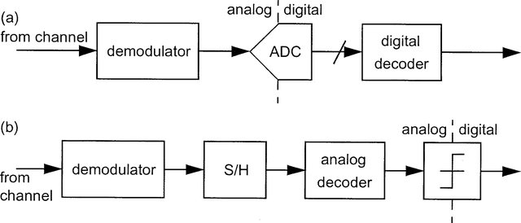

Fig [1.4]: Analog to Digital & Vice- Versa

• **Book References:**

<https://www.amazon.in/Introduction-Digital-Electronics-Essential/dp/0340645709> Introduction to Digital Electronics by by J. Crowe (Author), Barrie Hayes-Gill (Author)-Amazon link

<https://www.amazon.in/Introduction-Modern-Digital-Electronics/dp/1891121073>Introduction to Modern Digital Electronics by Charles Hawkins (Author), Jaume Segura (Author) –Amazon link

**Video lecture:**

<https://nptel.ac.in/courses/117/106/117106086/> Introduction to Digital Electronics by NPTEL.

• **Source**: NPTEL,IIT Delhi,NESCO Academy,MIT.